Jennifer Daniel

CIT480

Chapter 10 Exercises

**Exercise 10-1:**

10-1 Part 1/2:

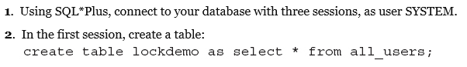



10-1 Part 3:

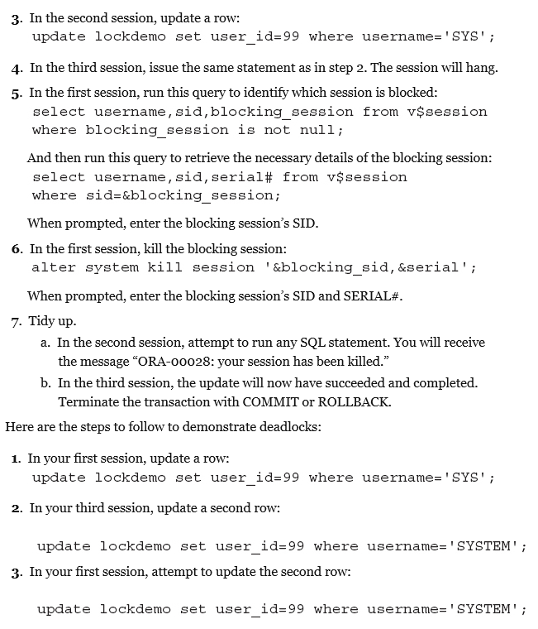



10-1 Part 4:





10-1 Part 5:



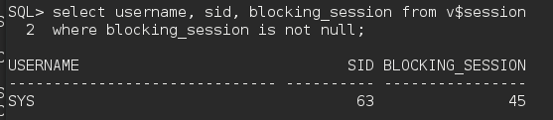

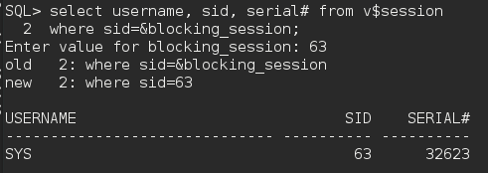

10-1 Part 6:



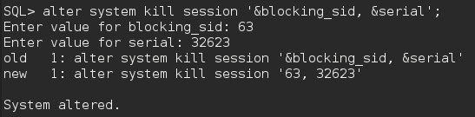



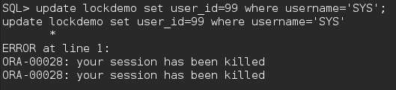





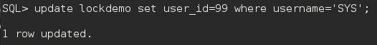







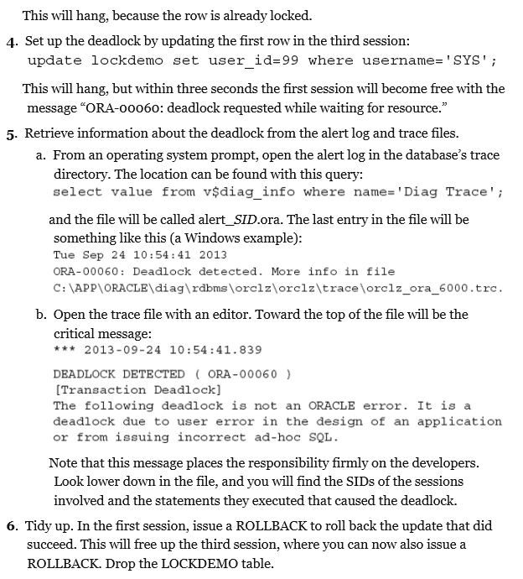







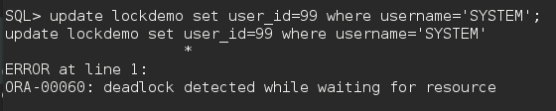



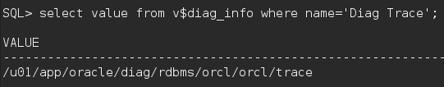





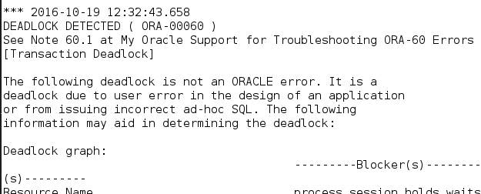

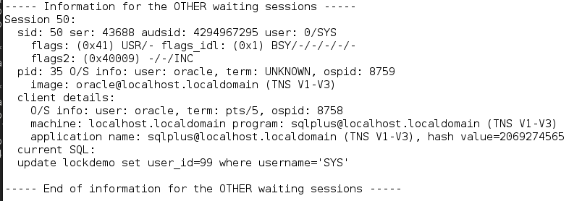



First session:

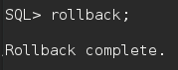

Third session:

